Order Of Service

Singing: Psalm 45—CW page 83

Reading: Psalm 28

Opening Hymn: TLH 87

Reading: Revelation 10

Request Hymn: CW Supplement 707

Reading: John 7:1-9

Sermon Hymn: TLH 656

Sermon Text: Song Of Solomon 5:7

Wounded & Robbed

Prayer

The Apostles’ Creed, TLH page 12

Holy Communion

The Lord's Prayer

The Blessing

Closing Hymn: TLH 94

* * * * * * * * * * *

Bible Study: Lambs: Psalm 18:2; Trust In God
Sheep; Proverbs 12:8-13
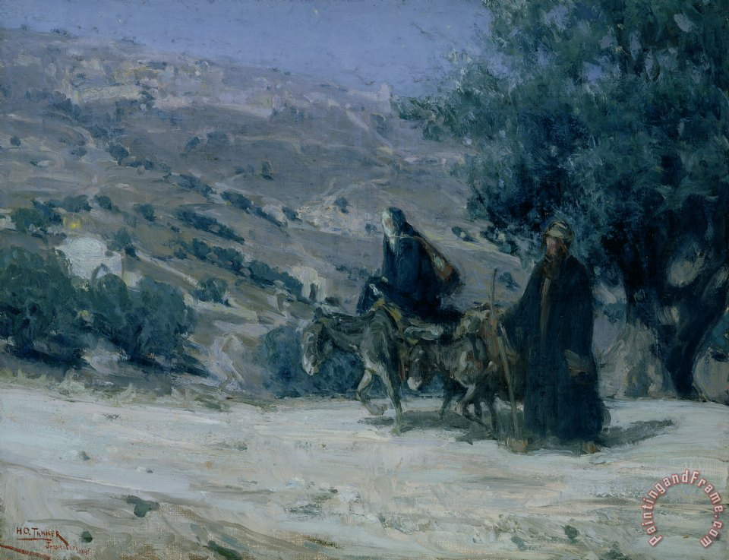

Night Flight Into Egypt

Water
Of
Life

25 December 2016

W A T E R O F L I F E

Independent Christian Church—Conservative Lutheran Doctrine

Worship Service: 9:30 a.m. Bible Study: 10:45 a.m.

Larry Cooper, Pastor E-Mail address:
111 N. Ridge Road lcooper@wateroflife.cc
Coon Valley, WI 54623 Web Site:
Phone: (608) 452-2105 www.wateroflife.cc

* * * * * * * * * * * * * * * * * * * * * * * * * * *

Sermon Text: Song Of Solomon 5:7

Wounded & Robbed

* * * * * * * * * * * * * * * * * * * * * * * * * * *

Song of Solomon 5:7 The watchmen that went about the city found me, they smote me, they wounded me; the keepers of the walls took away my veil from me.

In Genesis 3:1 we read: “Now the serpent was more subtil than any beast of the field which the LORD God had made. And he said unto the woman, Yea, hath God said, Ye shall not eat of every tree of the garden?”

Paging ahead to Genesis 10:8-9 the Holy Spirit tells us: “And Cush begat Nimrod: he began to be a mighty one in the earth. He was a mighty hunter before the LORD: wherefore it is said, Even as Nimrod the mighty hunter before the LORD.” The name “Nimrod” means “The Rebel.”

So early on in the very first book of Scripture the Holy Spirit reveals to us the two main modes of Satan’s attacks against God’s people. Sometimes he attacks in a very subtle manner—like a serpent. Other times he attacks viciously—like a lion.

Here in Song Of Solomon 5:7 we see Satan making a vicious attack against the Bride of Christ.



The human instruments Satan uses against her are the watchmen that went about the city, and the keepers of the walls. The watchmen are not strangers to us. We met them before in Song of Solomon 3:3. There they were silent. They had no idea where the Bridegroom was whom the Bride was seeking. Here in 5:7 their silence is broken. And with the keepers of the walls they break out in open persecution of the Bride. Just who are these vicious enemies of Christ and his Bride?

